**Functions and recursive functions**

0] Write a function to calculate the volume of a sphere.

Call the function in main, with parameter radius = 1.5, and print the result.

1] A recursive sequence {ai} is defined as follows:

an = 2∙an-1 + 3, if n > 0

a0 = 5

Calculate **a3**, showing all the steps in the recursion chain, down, and then up:

A3

= 2 * A2 + 3

= 2 * (2 * A1 + 3) + 3

= 2 * (2 * (2 * A0 + 3) + 3) + 3

= 2 * (2 * (2 * 5 + 3) + 3) + 3

= 61

3] A recursive sequence {ai} is defined as follows:

a0 = 0, a1 = 1, a2 = 1

an = an-2 + an-3, if n>3

Calculate **a5**, showing the entire recursion tree:

A5

= A3 + A2

= (A1 + A0) + A2

= (1 + 0) + 1

= 2

**Problems for report**

Note: For all problems marked with ►, take screenshots of both code and output, paste the screenshots in the report file.

1] A recursive sequence {ai} is defined as follows:

an = (an-1 + 1)2/2, if n>0

a0 = 1

Calculate **a3**, showing all the steps in the recursion chain:

A3

= (A2 + 1)2 / 2

= (((A1 + 1)2 / 2) + 1)2 / 2

= (((((A0 + 1)2 / 2) + 1)2 / 2) + 1)2 / 2

= (((((1 + 1)2 / 2) + 1)2 / 2) + 1)2 / 2

= 12

2] ►Implement the function above in a program, and test to make sure you got the same result.

3] A recursive sequence {ai} is defined as follows:

a0 = -1, a1 = 1, a2 = 0.5

an = an-2 * an-3

Calculate **a5**, showing the entire recursion tree:

A5

= A3 * A2

= (A1 * A0) * 0.5

= (1 * -1) * 0.5

= -0.5

4] ►Implement the function above in a program, and test to make sure you got the same result.

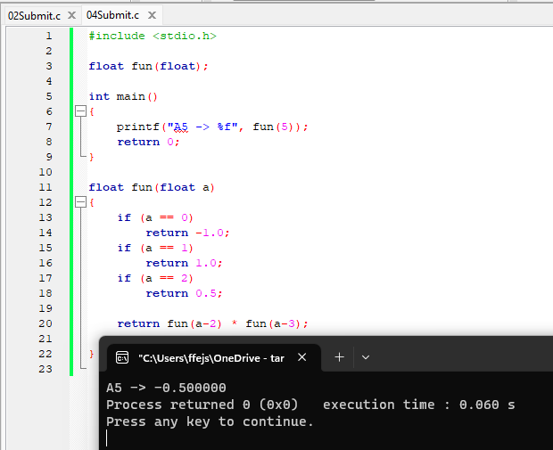

5] ► Write a recursive function **multiply(a, b)**, where a and b are both positive integers. You can only use the + and – operators, no *.

* Hint: Multiplication is repeated addition! We can recursively write a * b = (a-1) * b + b.

Test with a = 4, b = 5.

